Step 1. Automated Unit Testing
Step 2. Refactoring
Step 3. Automated Building

Executive Summary
Developers need to keep the rhythm of the cycle; creating unit tests, refactoring and changing, and getting feedback in a day to day coding. Automated Build will give developers fast, aggregated feedback of this cycle, closing the loop of this continuous rhythm as well as relief from the pain of manual build process. Each build tasks are coded into the build script along with running whole suite of unit tests task and building project is a matter of a mouse click. Continuous Integration leverages this automated building to make this whole cycle even more automated and frequent in terms of integrating all works from development team, and detecting errors and giving feedback as quickly as possible.
With this three step systemic approach, developers will be comfortable making changes and reduce the risk of introducing bugs at the same time.

Introduction
It has been a long time since I wrote about Unit Testing and Refactoring. Are you having fun with them? I became addicted to the fast feedback that this best practice delivers. It gives me a continuous rhythm of coding and keeps me focusing on what I am doing. Also, I feel better whenever I get rid of duplication and make the software design better by applying refactoring techniques. One last thing that I didn’t like was tedious, manual build process. Every time we built, I had to increase the version number of every version related files, change the related settings, create necessary files, copy reference libraries, build the project, create document, copy output files into the specific folder, check in modified files to source repository, and label the sources that just succeeded building. Oh, I forgot to test the whole project! Are you experiencing what I had experienced before? I badly wanted a build process that can do all these with just a mouse click, just like good old “make”.

Why Automated Building?
Some can say that Visual Studio IDE is enough for building the software for release. And it is true for really small and simple project that requires just a couple of manual steps to build. In that case, a separate build tool may be overhead. However, developers usually deal with more complex projects which require many steps to build, like I mentioned in the Introduction. Even with small project, you will get benefit by one click build process that can do many things automatically for you, eliminating tedious manual steps. Automated Building is essential when two or more people are involved in a project. It can give you an instant feedback of whether the build and the suite of unit tests developed by many developers are successful or not. It gives you repeatability of the build process as well, enabling any other members of the project to build the project in a repeatable, consistent manner. It is also a fundamental building block of having build environment separate from development environment.

Build Environment
Have you ever experienced that project building failed mysteriously on your local box or a piece of software runs fine on your local workspace but fails when deployed? When you have a development, build and integrate environment in a same machine, most likely, you will get in trouble facing those problems. Having physically separate environment gives you the ability to identify the problem faster. Also, imagine building whole project, getting feedback of that build and being ready for deployment, with just a mouse click, even if you do not have all the latest source codes, developed by many developers, available on your local workspace! You can also set up the scheduled build on this environment. These are some benefits of having separate build environment. Currently, many projects in our team (PCIIT – Dev Architecture) have been integrated with this automated build process and we have separate build and integration environment. As a result, we are experiencing many benefits out of it. In one instance, we were able to identify that one developer’s code change broke the other developer’s test in the automated build process. Had we not developed tests and not incorporated testing in the automated build process, it would have been slipped into the integration environment and it would have taken a lot longer time to catch that error.

Introducing NAnt Build Tool
NAnt is the build scripting tool ported from Java counterpart, Ant, and MSBuild is the build tool developed along with .net 2.0 by Microsoft which is inspired by Ant. These are xml based build script tools and share same core concepts. Therefore, once you learn one tool, it is easy to understand others. I will introduce automated building concept using NAnt with an example and gives you an idea of how to utilize MSBuild in the last part of this article.

Setting up the build machine
NAnt, NAnt Contrib, VS2003 or VS2005 (You don’t need to install VS2005 since MSBuild can build whole project without it but this demo requires it. I will show you how in the Automaton section), NUnit, VSS, CruiseControl.net (http://sourceforge.net/project/showfiles.php?group_id=71179&package_id=83198&release_id=459497). Install everything on a machine which we will call build machine. Ideally, this should be a separate machine from developers’ desktop.

NAnt in action
Download bankaccount3.zip and add solution to the root of the VSS. Type “NAnt.exe -D:solution.config=release” inside the Visual Studio command shell. You will see NAnt running and building the solution and testing outputs.

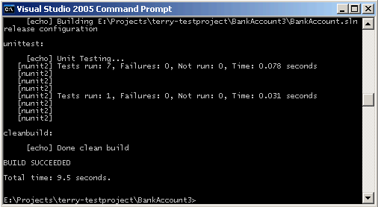

NAnt build file
You need to understand NAnt build file in order to understand how it works. It is xml format instead of command lines appear in DOS batch files. Each element is a keyword to be interpreted into a specific variable, directive and task. Extension point of NAnt is task – you can create your own tasks in addition to built-in tasks. A good start point in the NAnt document is “fundamentals”, which gives you basic concepts.

Let’s look at the build file, “BankAccount.build”
- Basic elements
Basic elements you need to have in the configuration file are <project> element, which is the root element, and one or more <target> elements. You can specify default target, to be called when NAnt is executed, in the project element or pass the target name as command line parameter.
NAnt will call each target in “BankAccount.build” following order:

clean -> init -> checkusernameandpassword -> getlatest -> build -> unittest -> cleanbuild

A target gets executed only once, even when more than one target depends on it as opposed to <call> task which executes target and its dependent targets every time it gets called.

- Property
The <property> element defines the variable in NAnt. You need to use special format, “${property.name}” to refer a property like below,

<property name="vss.dbfolder" value="F:\SourceCode" />
<property name="vss.dbpath" value="${vss.dbfolder}\srcsafe.ini" />

- Function
NAnt provides various built in functions that you can use in the configuration file. For example, it provides “file” related functions like below,

${file::exists('devenv.log')}

Which checks if “devenv.log” exists in the current folder and return true or false. You can refer “funcation reference” section in the NAnt document to look up these functions. You can define your own functions if NAnt does not provide.

- Task
Actual works are being executed in a form of task. NAnt Contrib open source project is the NAnt task extension project. Visual SourceSafe tasks were developed by this project. You can also execute the command line using “exec” task if there is no task provided.

<vssget username="${username}" password="${password}" localpath="${solution.basepath}" recursive="true" replace="true" dbpath="${sourcesafe.dbpath}" path="${sourcesafe.solution.basepath}" />

<exec program="devenv" commandline="&quot;${solution.fullpath}&quot; /rebuild ${solution.config} /out devenv.log" />

- The “nunit2” task
There is a very convenient way to incorporate unit tests into build process via NAnt task, “nunit2”. You can just define a couple of parameters and specify dlls that you want to test and nunit2 task will take care of the rest.

<nunit2 verbose="true">
<formatter type="Plain" />
<test assemblyname="${solution.basepath}\Bank\bin\${solution.config}\Bank.dll" />
<test assemblyname="${solution.basepath}\InterestController\bin\${solution.config}\InterestController.dll" />
</nunit2>

Now you are equipped with NAnt build script and it will build your project with one line of command. This is better than tedious manual building, right? However, we can go further by setting up the Continuous Integration environment.

Continuous Integration
Continuous Integration is a software development practice where members of a team integrate their work frequently, usually each person integrates at least daily - leading to multiple integrations per day. Each integration is verified by an automated build (including test) to detect integration errors as quickly as possible. Many teams find that this approach leads to significantly reduced integration problems and allows a team to develop cohesive software more rapidly. – Martin Fowler [Fowler]

CruiseControl.net
With CruiseControl.net, you can kick off build process with a mouse click and/or a check-in event from source control application, which is core Continuous Integration mechanism. The client system tray gives you feedback whether the build is succeeded or not.

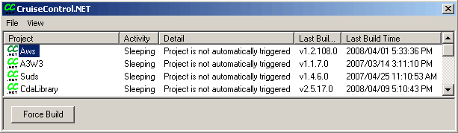.

You can refer the document on the CruiseControl.NET website (http://confluence.public.thoughtworks.org/display/CCNET/Welcome+to+CruiseControl.NET) to configure the tool and look at the sample configuration and build file, ccnet.config and ccnetbootstrap.build accordingly, that I included in BankAccount3 project.

MSBuild, Visual Studio Team Build, and Automaton
From Visual Studio 2005, Microsoft introduced its own build tool called, MSBuild and the project/solution files are actually build file for MSBuild. Also, Team Foundation Server has built-in tool to define the build type and kick off the build called, Team Build.

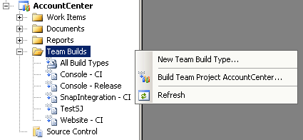

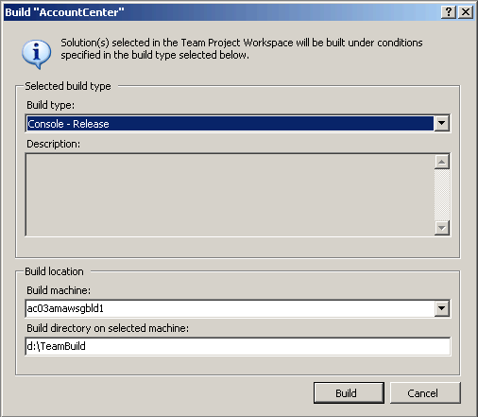

If you want Continuous Integration with Team Build you need Automaton (http://www.codeplex.com/Automaton). When you complete the “configuration wizard” via “Configure the Server” link, any build type defined in the Team Build will be automatically listed in the dashboard and registered with check-in event. After that, any check-in will kick off the build. You can set up the Alert in the Team System and receive an email whenever there is a build failure. Play with your own build types on Dev Architecture’s build server (http://ac03amawsgbld1/Automaton/) which is pointing to tfsprod. If you need sample build type, look at the AccountCenter team project on tfsprod Team Foundation Server.

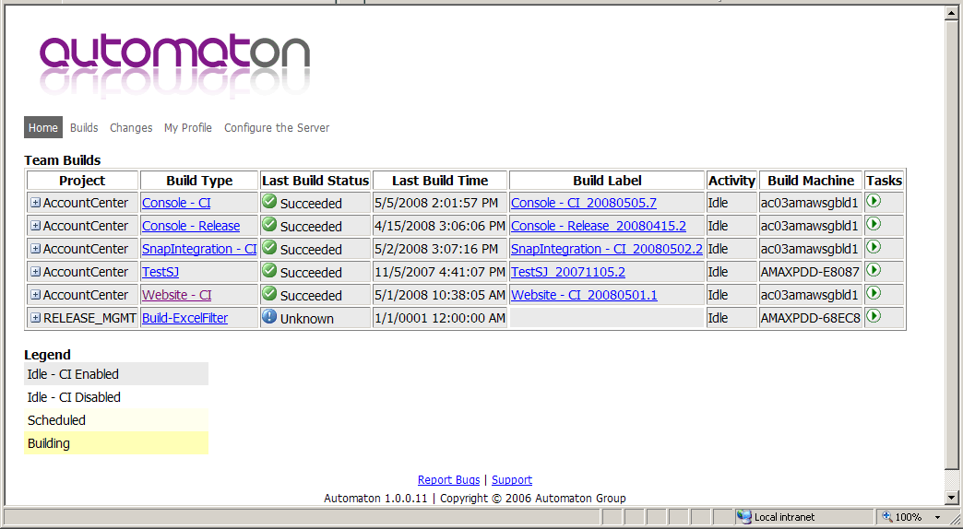

Things to Remember and Wrap Up
Here are some points that you should remember.
  - Create tests before you make any changes or even before you write code.
  - Apply Refactoring as much as possible to enhance your design while making changes.
  - Automate your tedious build process and integrate you tests.
  - Set up the Continuous Integration environment and build whenever there is check-in.
  - Get fast feedback.

My experience with Automated Build process and Continuous Integration is that there is no downside once it is set up, only benefits will come out from it and you will love the fast feedback it gives. The toll that you are paying is the time to set it up. Hopefully, this article will reduce the amount of time that you have to pay for it.

Wrapping Up the Series
Software Change is unavoidable. Therefore, developers should be prepared to face it rather than deny it. With this three step systemic approach, Unit Testing, Refactoring, and Continuous Integration, developers will be comfortable making changes, reduce the risk of introducing bugs, and improve the code at the same time.

Reference
[Fowler] Continuous Integration - http://www.martinfowler.com/articles/continuousIntegration.html

